**CHIME ABM Version 2.0 Full Description (ODD Specification)**

(Updated September 2020)

**1. Overview and NetLogo Implementation**

CHIME ABM was designed to investigate the dynamics of hazardous weather communication and decision making systems, in the context of evolving hazard forecasts and the complex modern information environment. To ensure that the model included important elements, dynamics, and interactions needed to address the questions of interest and enable extensions for future research, it was conceptualized and implemented through interdisciplinary collaboration incorporating in-depth knowledge about key aspects of such systems (section 2). This knowledge was incorporated through the expertise of the research team (which included physical scientists, social scientists, computer and information scientists, and agent-based modelers interacting within a larger, multi-method project; see Morss et al., BAMS, 2017) and reviews of relevant literature.

CHIME ABM includes a modeled world consisting of a spatially explicit geographical area of interest, a dynamic hazard that moves through that world, evolving forecast information about that hazard, and a multi-agent model in which different types of information related to the hazard are communicated among agents and used in protective decision making. As the world evolves, a forecaster periodically injects new forecast information into the multi-agent model. That information is then accessed, interpreted, and circulated within the model by media, public official, and citizen agents interacting in social and information networks. Public official agents can issue protective action recommendations, which are accessed and interpreted by citizen agents along with environmental cues from the hazard once it begins to affect their location. As they collect new information from different sources, citizen agents process that information, interpret it to assess their risk, and make decisions about protective actions.

The model described here has been developed and tested in the NetLogo (6.1) modeling environment. NetLogo provides a platform to implement an ABM with various data inputs (such as GIS data sets) and perform and document results from a variety of experiments. The model interface is shown in Figure 1. The model relies heavily on the Netlogo GIS extension and maps of spatial data imported from several sources (described below). Previous versions of the model are available at <https://www.comses.net/codebases/5504/releases/1.4.0/>

The NetLogo code is available and thoroughly commented as a companion to this description. The model and supporting files are available for download on the COMSES model library (www.comses.net). The supporting files necessary to initialize and run a simulation for hurricane Wilma (2005) are listed in Tables 1a and 1b, though a similar set of supporting files is available for hurricane Charley (2004) and variations of both Wilma and Charley with idealized/perfect forecasts. Additional supporting files can be created by the user for other locations and storms (see overview in section 5).

Figure 1. CHIME ABM interface, including various user-adjustable parameters (left) and depiction of the modeled world (right). The image is a screenshot taken from a simulation of Hurricane Irma approaching Florida, USA, with the real historic forecasts and 4400 citizen agents distributed according to US Census data. The depiction of the modeled world includes land (black) and ocean (dark blue), the storm (large white tropical cyclone symbol), the most recent forecast track with error bars (intersecting colored lines), and agents (small colored symbols over land).

Table 1a. Supporting input map and population files needed for running CHIME ABM V1 in Florida

File name Type Data

block_density.prj GIS projection map projection of Census blocks in FL (year 2000)

counties_1.asc GIS ascii grid cells assigned to FL counties

county_seats.dbf GIS shapefile dbf supporting file for county_seats.prj

county_seats.prj GIS shapefile prj supporting file for county _seats.prj

county_seats.shp GIS shapefile shp location of FL county seats

county_seats.shx GIS shapefile shx supporting file for county_seats.prj

Florida_SRTM_2015.asc GIS ascii DEM elevation in FL

Pop_Density_1215.asc GIS ascii population density by pixel in FL

Table 1b. Supporting storm and forecast input files needed for running CHIME ABM v.1 for a single hurricane (here, Hurricane Wilma)

File name Type Data

WILMA NEW.csv text file see Table 2a

WILMA ADVISORIES.txt text file index of the 20 Wilma forecast advisory files

Wilma_For_18.txt… text file Wilma forecast advisories 18-37 (see Table 2b)

**2. Design: Agents, Environment, and Processes**

*2.1 Design Concepts*

As discussed in section 1, CHIME ABM V1 includes multiple components, which are conceptually and numerically interconnected as depicted in Figure 2. The time step, geography, and representations of the hazard, forecasts, and agents in the current implementation of the model were designed to simulate decision making in response to a hurricane (tropical cyclone) threatening the US coastline. However, the model was designed to represent fundamental features of hazard information and decision systems and thus to be adaptable to other geophysical hazards.

Figure 2.

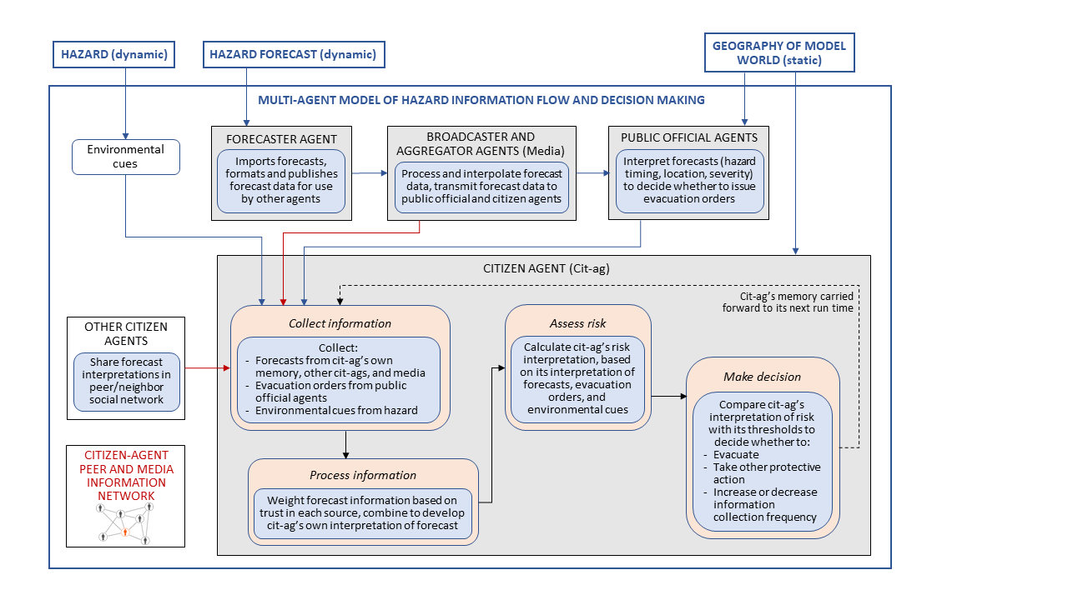

Figure 2. Diagrammatic representation of the conceptual model underlying the agent-based model.

To design and implement the model, we integrated expertise in agent-based modeling with knowledge and data from research and operational meteorology, emergency management, risk communication, information science, social vulnerabilities, and protective decision making. As in any modeling effort of this type, many aspects of CHIME ABM are abstracted or simplified from the real world, and some real-world features and processes are not represented. Decisions about what to include in the model and how to represent it were based on cross-disciplinary discussions among our research team, interactions with the larger research project discussed in Morss et al. (BAMS, 2017), and review of relevant literature.

The modeling platform was designed to represent key aspects of the real-world system of interest given our research goals, while remaining sufficiently simple to allow meaningful exploration and knowledge building. The representations of an approaching hurricane and hurricane forecast information were designed based on current knowledge and practices in atmospheric and related sciences. The representations of hazard information flow and decision making were designed based on current knowledge and practices in modern hazard forecast and warning systems, in which heterogeneous agents interact via different peer and media networks to create, communicate, interpret, and use multiple types of risk information from multiple sources. We included five agent types to represent five important types of actors in present-day hazard forecast and warning systems — forecasters, public officials, media broadcasters, other media aggregators and communicators, and citizens with varying individual characteristics — and designed those agents to represent key behaviors of real-world actors in the context of US hurricane threats. As in the real world, we designed the agents to interact with each other and with a virtual world with ocean and land areas, a hurricane that moves across the landscape, and forecast and other risk information that evolves as the storm approaches. Within this system, the risk information available and associated uncertainties change across space and through time. To represent the modern, hyper-connected environment, we included in the model the capability for information to be widely exchanged almost instantaneously

The most complex component of the current version of CHIME ABM is the citizen-agent decision model. We designed this component of the ABM based on current understanding about how at-risk members of the public access and use risk information and make protective decisions when a hurricane threatens, based on the large body of empirical research using interviews, surveys, and other methods approached from multiple disciplinary and interdisciplinary perspectives (see, e.g., reviews in Baker, International Journal of Mass Emergencies and Disasters, 1991; Dash and Gladwin, Risk Analysis, 2007; Lazo et al., Risk Analysis, 2015; and Huang et al., Environment and Behavior, 2016). As discussed in these reviews and other literature, existing research indicates that, in general, people evacuate when they believe that an approaching hurricane poses a risk to their own or their family’s safety, and that different people can both perceive risk differently and have different evacuation barriers or constraints. Thus, we formulated the citizen-agent decision module in terms of citizen-agents combining and translating information obtained from multiple sources into a risk assessment, which is then compared with decision thresholds that vary across the citizen-agent population. The formulation of the information used by citizen-agents was based on previous and concurrent work indicating that forecasts and associated uncertainties, perceived residence in an evacuation or high-risk zone, evacuation orders from public officials, and environmental cues are among the most important factors influencing how members of the public evaluate the risk of an approaching hurricane. These and other aspects of the model design are discussed in further detail below.

*2.2 The Modeled World, Storm, and Storm Forecasts*:

The world in this model is a representation of a US state or a geographical region comprised of several states.

A raster map adapted from Florida census data (population density in census tracts for the year 2000) is imported into NetLogo (Population_Density.asc) and applied to the grid cells (each grid cell is 3.193 nm2 or 3.674 mi2); these data are later used to distribute citizen agents geographically in semi-realistic manner, for simulations using realistic population distributions.

None of the imported or underlying map characteristics are dynamic; i.e., for the duration of the simulation, agents do not modify the landscape in any way, and the landscape itself does not change through time. Other locations (real or imagined) can be used to generate the model’s map, so long as the GIS layers imported into NetLogo (Table 1a) are formatted appropriately. The relevant supporting files and variables are summarized in the remainder of this section; additional information about the file and variable formats can be found in the section 5.

Alongside the static characteristics of the modeled world there is also a simulated tropical cyclone that impacts Florida. The storm is included for visualization (as in Figure 1), for providing environmental cues from the storm once it begins to affect populated areas, and for analyzing and interpreting the model output. In the current version of the model, the storm is represented in simplified form, since the focus of initial experiments with the model is human information networks and decision making related to the time before the storm arrives; however, this can be elaborated in subsequent versions. Two major hurricanes that crossed Florida, Hurricanes Wilma (2005) and Charley (2004), were used for the initial development and testing of the model. Subsequently, Harvey, Irma, and Michael have also been to the CHIME ABM and instructions for adding new storms are described below.

To represent key characteristics of the storms and their evolution in the model, historical storm data for Wilma and Charley were downloaded from the U.S. NOAA/NHC (National Oceanic and Atmospheric Administration / National Hurricane Center, http://www.nhc.noaa.gov/) website and imported into NetLogo. For each hurricane, the storm data file (e.g., file WILMA.txt) includes information about the storm’s location, intensity, and wind speeds in four quadrants (Table 2a) every 6 hours, starting from about 100 hours before that storm’s first landfall to about 20 hours after its first landfall (see section 5). These times were selected based on the evolution of Wilma and Charley; they can be adjusted as needed for different storms. Together, the sequence of storm locations form the storm’s track.

To represent forecasts of the storm, V1 of the ABM has two options: 1) historical forecasts, and 2) ideal forecasts. The “historical forecast” option uses the sequence of advisories for that storm (either Wilma or Charley) that was generated by the NHC as the storm approached. The “historical forecast” data (e.g., files Wilma_For_18.txt, etc.; see section 5) used by the model was read in from the published data available on the NOAA website (Table 2b). The “ideal forecast” option uses the actual storm data (from Table 2a) to reconstruct a perfect forecast; these were generated outside of the ABM in the format of the NOAA published historical data (see section 5 for file naming). Note that V1 does not use the forecasted storm wind radii; it uses only the forecasted locations and maximum sustained winds. The forecast wind radii data were extracted and retained in the model, however, because they are in the NHC Advisory files and could be used in future versions of the model algorithms.

In V1, forecast uncertainty is represented in terms of uncertainty in the hurricane’s track, using data from NHC about the “cone of uncertainty” (which estimates uncertainty in the track forecast at different forecast lead times based on average errors in recent track forecasts; see <http://www.nhc.noaa.gov/aboutcone.shtml>). Here, we use historical cone of uncertainty data from 2005, when Wilma and Charley made landfall. The cone is published by the NHC as a sequence of 7 increasing distances that correspond to track errors in 12, 24, 36, 48, 72, 96, and 120 hour forecasts, e.g., 44, 77, 111, 143, 208, 266, and 357 nautical miles in 2005.

Table 2a. Representations of the evolving storm in CHIME ABM V1.

|  |
| --- |
| **Storm Characteristics**  **(typically updated every 6 hours)** |
| Geographic coordinates (representing location of hurricane eye) |
| Maximum sustained winds (representing hurricane intensity) |
| Radius of 64, 50, and 34 kt wind speeds in each of 4 quadrants |
| Minimum central barometric pressure |

Table 2b. Representations of the evolving forecast information in CHIME ABM V1.

|  |
| --- |
| **Forecast Information**  **(typically updated every 6 hours; files Wilma_For_18.txt, Wilma_For_19.txt, etc.)** |
| Forecasted geographic coordinates (location of eye), typically provided for approximately 12, 24, 36, 48, 72, 96, and 120 hours from forecast initialization time |
| Forecasted maximum sustained winds, typically provided for approximately 12, 24, 36, 48, 72, 96, and 120 hours from forecast initialization time |
| Forecasted radius of 64, 50, and 34 knot winds in each of 4 quadrants, typically provided for approximately 12, 24, 36, 48, 72, 96, and 120 hours from forecast initialization time |

In the model, time in the NetLogo simulated world is modeled as proceeding in hourly increments. World-related processes, such as the advancement of the hurricane, also occur in discrete hourly time steps. Likewise, the agent-related processes also occur in discrete time, but most of the agents run on a schedule and remain in a dormant state unless called to perform a task at a specific time.

*2.3 Agents*

Five types (or breeds) of agents have been defined (Table 3). The citizen agents and their decision making processes are the focus of initial research with CHIME ABM and thus have more sophisticated algorithms relative to the other agents; the other agent breeds are currently simple, but may be elaborated in subsequent revisions. Note that the commented code explains—by procedure and by line—the agents’ algorithms, though the important sub-models (e.g., the Cit-ags’ decision model and social network rules) are presented below. A list of defining parameters for each of the five agent breeds is presented in Tables 4 and 5.

Table 3. Overview of the five agent breeds in CHIME ABM V1.

|  |  |  |  |  |
| --- | --- | --- | --- | --- |
| **Breed** | **Count** | **Behaviors** | **Geographic distribution** | **Temporal scheduling** |
| Forecaster | 1 | Publishes forecast and forecast uncertainty information into model world | Random | Active at each time step (every hour) |
| Broadcasters | 1-10 | Republish forecast information from Forecaster, reformatted and temporally interpolated for use by other agents | Random | Active at each time step (every hour) |
| Aggregators | 1-10 | Same as Broadcasters | Random | Each Aggregator has a 1 in 3 (random) chance of being active at each time step |
| Officials | 67 | Interpret forecasts and assess risk to decide if and when to issue evacuation orders | One in each of the 67 FL counties | Each Official is active at every time step |
| Cit-ags | 500-5000 | Collect forecasts from various sources (media, other Cit-ags, own memory) and other information (evacuation orders, environmental cues); processes forecasts; share forecasts; interpret information to assess risk; and make decisions about evacuation and other actions | Random or according to Census information | Each Cit-ag is active every 1-32 time steps; scheduling is set randomly at initialization, with the time interval between active times changed if the Cit-ag decides to increase or decrease information collection frequency |

Table 4. Variables for the Forecaster, Broadcaster, Aggregator, and Public Official agent breeds. In V1, the static variables listed in this table are global (apply to all agents of that breed) and set at initialization.

|  |  |  |  |  |
| --- | --- | --- | --- | --- |
| **Breed** | **Variable** | **Type** | **Definition** | **Notes** |
| Forecaster | *forecast* | dynamic | imported forecast information from data file | historical (from NHC) or ideal (perfect) |
| Broadcasters | *broadcast* | dynamic | agent’s representation of the forecast | reorganized and temporally interpolated from *forecast* |
| Aggregators | *info* | dynamic | agent’s representation of the forecast | reorganized and temporally interpolated from *forecast* |
| Public officials | *wind-threshold* | static | wind exposure threshold that triggers an Official to issue an evacuation order | 70-130 knots; set at model interface |
|  | *earliest* | static | earliest lead time at which Officials are able to issue evacuation orders (based on the time until they think the storm’s eye will reach coastal locations in their county) | 0-78 hours; set at model interface |
|  | *latest* | static | latest lead time at which Officials are able to issue evacuation orders (based on the time until they think the storm’s eye will reach coastal locations in their county) | 0-12 hours; set at model interface (not used in V1 of model code) |
|  | *orders* | dynamic | 1 if that Official has issued an evacuation order; 0 if not | Boolean |

2.3.1 Forecaster agents

Forecaster agents function as weather forecasters (modeled after, e.g., the U.S. National Weather Service’s National Hurricane Center) who provide hurricane forecast information to the model world. There is one Forecaster, and its only job is to publish new forecast information (historical or idealized) as it is updated. This includes reformatting the forecast data from the format used in the input file (see section 5 below) and adding forecast uncertainty information (section 2.1).

At each time step, the Forecaster checks for updated forecast information (in the variable *forecast-matrix* loaded from the forecast files at model setup as described below), and, if there is an updated forecast, formats that data into the forecast representation used within the ABM. While the Forecaster has no need for a physical presence in the V1 modeled world, in the current NetLogo implementation the Forecaster agent is represented by a small green circle placed at random somewhere in the model’s geographic land domain. Future versions of the model could be extended to include multiple Forecasters, importing or generating different forecasts.

Relevant NetLogo procedures:

* + - *Load-Forecasts and Load-Forecasts-New*: One of these procedures is run once at model setup; reads in files containing the historic or ideal forecasts and parses them into variable *forecast-matrix*, which is a matrix representation of all of the forecasts available in the model world. The procedure run is dependent on the storm that is being tested.
    - *Publish-Forecasts*: run every time step; selects the most recent forecast from variable *forecast-matrix*, which includes the variables in Table 2b (forecasted storm location, maximum sustained winds, and wind radii in 4 quadrants) every 12-24 hours out to three to five days in the future, formats that data, adds data on uncertainty in the forecasted storm position for each forecast time (from NHC “cone of uncertainty”; see section 2.2), publishes forecast as variable *forecast* for use by other agents.

2.3.2 Broadcaster agents

Broadcasters abstractly model the role of traditional media, such as television, in communicating weather forecast and warning information to a broad audience. The important job of Broadcasters is to interpolate and reformat the forecast published by the Forecaster into storm information that can be interpreted by the other agents. They take the *forecast* variable, which contains forecast and track forecast uncertainty information every 12-24 hours, select the forecast time period most relevant to when the hurricane will affect the model domain, and interpolate that forecast information to an hourly forecast that can be read by the other agents. They then publish this information as their current *broadcast*.

At each time step each Broadcaster updates their broadcast. A typical simulation is initialized with 1 to 10 Broadcasters. Currently, the Broadcasters do not modify the content of the forecast; this could be revised in future versions. Though Broadcasters have no need for a physical presence in the V1 modeled world, in the current NetLogo implementation they are shown as tiny yellow circles placed at random somewhere in the model’s geographic land domain.

Relevant NetLogo procedure:

* + - *Publish-New-Mental-Model*: run every time step; takes the *forecas*t variable output by the Forecaster, identifies the 12- or 24-hour time window in that forecast that is most relevant to the population in the model domain, interpolates to produce hourly forecasts within that time window, publishes the interpolated forecast and forecast uncertainty information as variable *broadcast* for use by the other agents.

2.3.3 Aggregator agents

Aggregators are intended to abstractly model the role of “new media” information actors who access, process, and redistribute forecast (and potentially other) information, e.g., on the internet or mobile devices. They are an underdeveloped aspect of the model and at present function identically to the Broadcaster agents, with two exceptions: they do not provide information to Public official agents, and they have a 1 in 3 random chance of running at each time step. Future revisions to the model may refine these agents to function more like web or smartphone news aggregators, with different distribution networks and information compared to the Broadcaster agents.

As with the Broadcasters, a typical simulation is set up with 1 to 10 Aggregators. Aggregators are depicted as tiny pink circles placed at random in the model domain.

2.3.4 Public official agents

Public officials (Officials) represent local government personnel who help protect the public and inform people about protective actions. Officials decide whether to issue evacuation orders, which influence citizen-agents’ interpretations of risk and help motivate citizen-agent evacuation decisions as a storm approaches.

In the current version of the model, an Official, depicted as a red star, is located at each of the 67 county seats in the state of Florida. During each timestep of the simulation, an Official uses the procedures described below to assess the potential for the storm to affect the Official’s county, based on the forecast and associated uncertainty, and if necessary issues evacuation orders. Only those Officials located in counties exposed to the ocean (coastal counties) can issue evacuation orders. Non-coastal county Officials do not participate in the current version of the model. Once an Official has decided to issue an evacuation order, that evacuation order remains in effect for the rest of the model simulation; the Official does not rerun its decision algorithm.

Officials’ decisions are based not on the risk posed to their own location, but on the risk to coastal locations in their county. Therefore each coastal cell in a county must interpret the forecast and uncertainty at that cell and to report back to its county’s Official as to whether orders are necessary.

At initialization, three global parameters important for the Officials are set: a *wind-threshold* and a time window (*earliest* and *latest*) for issuing evacuation orders (Table 4). All Officials use the same settings for these 3 parameters in any given simulation. The variable *wind-threshold* determines the wind speed (along their county’s coastline) over which Officials will issue evacuation orders, and *earliest* and *latest* define the time interval (prior to the storm reaching coastal locations in their county) during which the Officials can consider issuing orders.

Relevant NetLogo procedures:

* *Coastal-Patches-Alerts*: At every time step, each coastal cell runs this procedure to evaluate the risk at its location based on forecast information. To do so, each coastal grid cell first obtains a forecast from one of the Broadcasters (randomly selected). It then interprets that information to estimate the time until arrival of the storm at its location (based on the time when the eye of the storm is forecasted to come closest to its location, not considering the forecast uncertainty). The grid cell also assesses whether it is in the cone of uncertainty, and it checks the forecasted maximum sustained winds at the anticipated time of arrival. (Note that the maximum sustained winds from the forecast is used, not the winds at different radii in the quadrants.) If the grid cell estimates that 1) the time until arrival is between *earliest* and *latest*, 2) it is in the cone of uncertainty, and 3) the forecasted maximum sustained wind speed at the time of arrival is greater than *wind-threshold*, then it sets its *orders* variable to 1.
* *Issue-Alerts*: At each time step, each coastal-county Official checks the coastal grid cells in its county to see whether any of them have decided that an evacuation order should be issued (based on the procedure “coastal-patches-alerts”). If any of the grid cells report back 1 for its *orders* variable, then the Official publishes evacuation orders (set its *orders* variable to 1).

2.3.5 Citizen-Agents

Citizen-Agents model members of the public who collect information about incoming storms from various sources and decide whether the risk is serious enough to take some form of protective action. Citizen-Agents are themselves information transmitters, relaying their interpretation of storm forecasts to other citizen-agents in their social networks. While the model does not explicitly define whether a citizen-agent represents an actual biological individual, or the collective decision-making of the members of a household, it is best to think of the citizen-agent as capturing the behavior of a person or small group that is responsible for making protective action decisions. Importantly, though, this ABM does not explicitly model citizen-agents actually evacuating (moving their location) or taking other physical protective actions; it is focused on decision making. However, one protective action option available to agents is to decide to collect information about the storm more frequently; this does change their behavior, by resulting in more-frequent calls to their decision-making code.

The number of citizen-agents included in a simulation is set by a slider on the model interface (V1: usually between 500-5000). In V1, two options are available for geographically distributing those Cit-ags: a) randomly, and b) such that their relative density corresponds to the real-world population density in the model domain (in V1, Florida, according to the 2000 census data file input). At initialization, the Cit-ags are shown as small blue circles. If a Cit-ag decides to take a non-evacuation protective action, its color changes to green, and then to orange if it decides to evacuate. Detailed descriptions of the Cit-ag algorithms/procedures are provided in section 4 below.

**3. Initializing the Model and Running Simulations**

The various inputs needed to run a simulation are loaded when the model is initialized, including map layers, storm information, and forecasts. Details on the input files (formats, sources, file names) are provided in section 5 below. To initialize a simulation in NetLogo, the user first selects the storm of interest from a pull-down menu. Next, the “Setup Simulation” button 1. imports the necessary map files to set up the world and provide information to agents, 2. imports a text file (comma delimited, e.g., WILMA_NEW.csv) with details on the evolution of the storm track, intensity, etc., as described in Table 2a. and 3. checks an index file (e.g. WILMA ADVISORIES.txt) with a list of forecast advisory files to import for the selected storm. Depending on the storm, that index may list all of the advisories for a storm, or a subset of advisories relevant to the geographical area of interest (i.e., Wilma was a long-lived storm both before and after crossing Florida, so the index only lists advisories relevant to approximately 5 days before and shortly after landfall). After checking the index, the appropriate forecast advisories (e.g., Wilma_For_18.txt, Wilma_For_19.txt, … Wilma_For_37.txt or Irma.csv) are then imported into the model (exactly as published by NHC/NOAA; see section 5) and the data used in the ABM is extracted: forecasted track, intensity, and wind radii (distance of 34, 50, and 64 kt winds from the eye in NE, SE, SW, NW quadrants) at multiple lead times, as described in Table 2b.

Next, the population of agents is distributed in the modeled world (e.g., citizen-agents are placed on the map, either randomly, consistent with population density for the 2000 census, or according to the location of census tracts). Pressing Run Simulation starts the clock and triggers the storm to evolve and every agent to run its breed-specific instructions/code according to its schedule.

As time proceeds in the simulation, the hurricane approaches and crosses the state of Florida, forecasts are published and distributed via various social and information networks, evacuation orders may be issued where appropriate, and citizen-agents assess their risk and determine if and when to take protective action. More specifically, at each time step, 1) if new storm characteristics are available from the storm information loaded from that data input file, the hurricane location, intensity, and size are updated, 2) if a new forecast is available from the forecast information loaded from those data input files, the Forecaster publishes the new forecast information, 3) Official agents run algorithms to decide whether to issue evacuation orders (if criteria are met), 4) non-dormant Broadcaster and Aggregator agents run algorithms to parse and interpolate the forecasts and reformat them for use by other agents, and 5) non-dormant citizen-agents run algorithms to collect information, assess risk, and make decisions about protective actions (scheduling for the citizen-agents is described below).

**4. Citizen-Agent Submodel Descriptions**

The following subsections describe the underlying sub-models that define the citizen agents’ decision making and the ways that citizen agents are connected to other agents (and the environment) to collect information relevant to their protective action decisions.

*4.1 Citizen-Agent Characteristics and Initialization*

Key citizen-agent specific variables are listed in Table 5. The static variables and the initial value of *feedback1* are set at initialization, as discussed below.

Table 5. Variables for Cit-ags. All static variables are local to each Cit-ag (vary across the Cit-ag population) and are set at initialization.

|  |  |  |  |
| --- | --- | --- | --- |
| **Variable** | **Type** | **Definition** | **Notes** |
| *network-list* | static | list of other Cit-ags in the Cit-ag’s information network | see section 4.1.4 |
| *broadcaster-list* | static | list of Broadcasters in Cit-ag’s information network | random subset of Broadcasters |
| *aggregator-list* | static | list of Aggregators in Cit-ag’s information network | random subset of Aggregators |
| *trust-score* | static | Cit-ag’s trust in each source of information (Broadcasters, Aggregators, other Cit-ags) in its network | for each source, random between 0 and 1 (stored in *broadcaster-list*, *aggregator-list*, *network-list* variables in model code) |
| *self-trust* | static | Cit-ag’s trust in its own previous interpretation of the forecast | random between 0.6 and 1 |
| *trust-authority?* | static | Cit-ag’s trust in information from Officials | random between 0 and 1 |
| *evac-zone* | static | Cit-ag’s representation of whether it lives in an evacuation zone | evacuation zone A is defined as 1.5 grid cells from the coast, B=1.5-3 cells, and C=3-5 cells (only A is considered in V1 of the model); each Cit-ag has a 1 in 5 chance (randomly generated) of incorrectly determining its zone |
| *risk-life* | static | Cit-ag’s threshold for risk to life; if *risk-estimate* is above this threshold, the agent will decide to evacuate | random-normal with mean 14, std. dev. 2 |
| *risk-property* | static | Cit-ag’s threshold for risk to concerns other than life (e.g., property); if *risk-estimate* is above this threshold, the agent will decide to take other (non-evacuation) protective actions | random-normal with mean 0.7\**risk-life*, std. dev. 0.5 |
| *info-up* | static | Cit-ag’s threshold for increasing frequency of information collection; if *risk-estimate* is above this threshold, the agent will decide to collect information more frequently | random-normal with mean 0.4\**risk-life*, std. dev. 0.5 |
| *info-down* | static | Cit-ag’s risk threshold for decreasing frequency of information collection; if *risk-estimate* is below this threshold, the agent will decide to collect information less frequently | random-normal with mean 0.1\**risk-life*, std. dev. 0.5 |
| *feedback1* | dynamic | number of time steps before Cit-ag’s next active time | integer; set at initialization to random-normal with mean 12, std. dev. 2; changes if Cit-ag decides to increase or decrease information collection frequency; min 1, max 32 |
| *environmental-cues* | dynamic | 1 if Cit-ag’s location is currently experiencing gale-force (34-knot) or greater winds, based on the current characteristics of the storm; 0 if not | Boolean |
| *interpreted-forecast* | dynamic | Cit-ag’s own interpretation of the forecast | see section 4.2.2 |
| *memory* | dynamic | Cit-ag’s previous interpretation of the forecast (from the last time step it was active) | stored previous value of *interp* |
| *risk-estimate* | dynamic | Cit-ag’s current assessment of risk | see section 4.2.3 |
| *affected?* | dynamic | maximum wind-exposure for Cit-ag’s location, set at end of simulation | for analysis only |
| *completed* | dynamic | list of Cit-ag’s previous protective-action decisions, for each time step when the Cit-ag was active | for analysis only |

4.1.1 Citizen-Agent Spatial Distribution

The ABM has three options for spatially distributing the Cit-ags: a) random, and b) placement consistent with real-world population density (as indicated by Census data). The random setting simply places each Cit-ag on a random non-water cell on the map. For realistic Cit-ag spatial distribution, the procedure aims to place concentrations of agents in different areas of the map as indicated by year 2000 Census data. To do this, the percentage of the state’s population in each census tract in the state is calculated, informed by the Population_Density.asc input file. Then the specified number of agents (a number between 500 and 5000 in the current version) is randomly placed in a census tract based on the weighting calculated above. Finally, the agents are jittered a small amount so that they aren’t all stacked in the center of a census tract, which also provides a better visual display of those agents in the NetLogo interface.

4.1.2 Citizen-Agent Characteristics

The static citizen-agent variables are summarized in Table 5; here we provide a brief overview, with more complex threshold and social network variables described further in separate subsections below. Each citizen-agent is initialized with randomly distributed trust scores for itself (how much to weigh its own “memory” of its interpretation of the forecast from the previous time step when it was non-dormant; variable *self-trust*) and for trust in the Official agents (how much to weigh evacuation orders; *trust-authority?*). Each citizen-agent also defines which Broadcasters and Aggregators are in its media network (variables *broadcaster-list*, *aggregator-list*), from whom it can obtain forecast information, and assigns trust scores to each of those sources.

Further, at initialization each citizen-agent assesses whether it is located in an evacuation zone (variable *evac-zone*). To do so, it evaluates whether it is located less than 1.5 grid cells from the coast (zone A), 1.5-3 grid cells from the coast (zone B), or 3-5 grid cells from the coast (zone C), but there is a 20% chance that a citizen-agent will mis-identify its zone.

4.1.3 Citizen-Agent Risk Thresholds

These agent-specific static variables are assigned to each citizen-agent at initialization. They are then utilized when that agent runs the Decision Model discussed below. For V1 of the model, values are set using the following rules:

1. *risk-life*-*threshold* is assigned as a normally-distributed random with a mean of 14 and a standard deviation of 2;
2. *risk-property* threshold takes 0.7 times the *risk-life* value, then uses that value as the mean of another normally-distributed random with a standard deviation of 0.5;
3. *increase-information* threshold takes 0.4 times the *risk-life* value, then uses that value as the mean of another normally-distributed random with a standard deviation of 0.5;
4. *decrease-information* threshold is calculated as normally-distributed random with a mean of .1 times the *risk-life* value with a standard deviation of 0.5.

4.1.4 Citizen-Agent Social and Information Networks

Citizen-Agents running the decision model rely on a social network of other connected citizen-agents as part of the information collection algorithm. This peer social network—combined with Broadcasters, Aggregators and Official agents—provides the pool of information that a citizen-agent uses to inform its risk assessment. The network-building routine described here was implemented to capture some aspects of real social networks and creates a scale-free network.

Citizen-Agents are connected to other Citizen-Agents in the model set up using two methods that are run sequentially in the code. The two main sets of instructions define the core part of each Citizen-Agent’s social network, which remains static for the duration of the current simulation. Note that the links between agents are bidirectional, such that information can flow both ways between agents. Note also that the distance restrictions mentioned below are not empirically based but were selected to increase the local density of social networks in a plausible way for this initial implementation; they could be tested in a sensitivity analysis or refined in future versions of the model.

The social network is static, defined at initialization. Every citizen-agent, in random order, executes the following algorithms to establish its social network. First, the agents are connected using a standard preferential attachment routine, with the condition that they only consider connecting to other citizen-agents located within a distance of *network-distance* grid units. Network-dsitance can be set in the user interface. The routine works by asking a randomly chosen citizen-agent to survey the local neighborhood of citizen-agents within *network-distance* grid cells. Those citizen-agents within that distance become the subset from which the current agent will select a new link. Each of the citizen-agents within this subset is assigned one “lottery ticket” for each of the social network connections it already has. Then a random ticket is chosen, and the holder of that ticket is linked to the citizen-agents running the code. Functionally, this process serves to create a relatively small number of highly central nodes in the network, while most of the citizen-agents have relatively fewer connections (i.e., an example of a scale-free network).

After all of the citizen-agents run the first procedure, they then run a second procedure. Because a traditional scale free network generated by preferential attachment is often far too sparse to model a real social network, the ABM also connects other citizen-agents to complete triads. In social network analysis this characteristic is known as “transitivity”. If agent A knows agent B, and if agent C knows agent B, then there is a high probability that agents A and C know each other. To capture this characteristic in the social networks model, the citizen-agents running the routine queries the network list of a citizen-agent they are already connected to, restricts their options to citizen-agents within *network-distance* grid unit distance, and makes a link to one of those agents (selected randomly).

The above algorithms form a static social network for each citizen-agent (variable *network-list*), defined at the beginning of each simulation. An example static social network produced by these algorithms is shown in Figure 3.

Figure 3

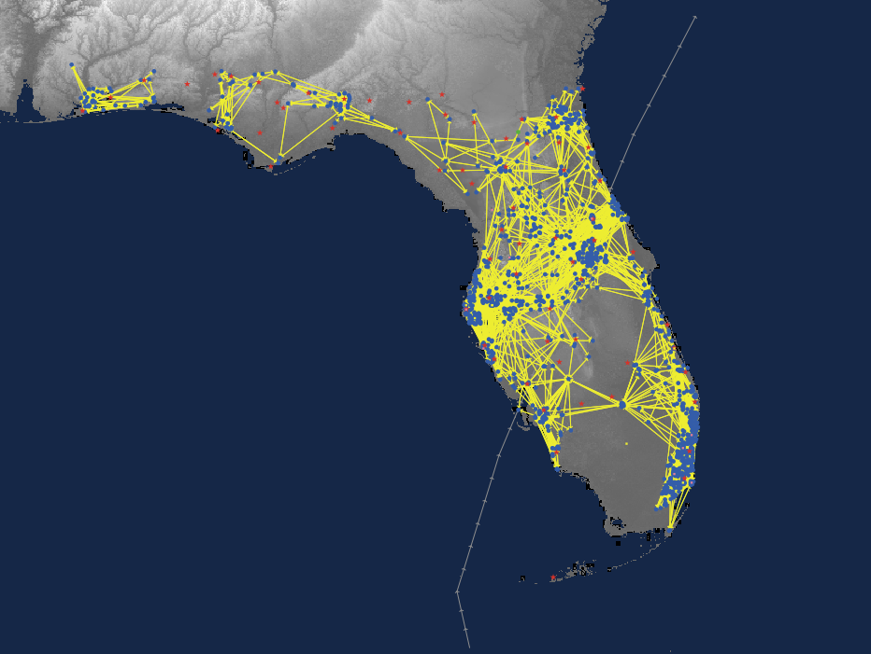

Figure 3. Example peer social network for 1250 Cit-ags.

*4.2* Citizen-Agent *Decision Model*

The implementation of the decision model was adapted from conceptual decision models such as the Protective Action Decision Model (PADM) (Lindell and Perry, Risk Analysis, 2012) as well as the empirical literature on information exchange and protective decision making for hurricanes and other natural hazards. The decision model used here was developed by J Watts and C M Barton in collaboration with R Morss and J Demuth, and is shown in Figure 2. One of the more important and difficult challenges of this project was to adapt the sort of abstract decision model in the PADM and the hazard decision making literature to provide simple—but highly specific—instructions for agents (i.e., algorithmic programming).

At each time step when a citizen-agent is active, it executes four algorithms: a) *collect* information about the storm, b) sort and *process* that information, c) use the information to *assess* risk, and d) *decide* whether to evacuate or take other action. Each citizen-agent runs all 4 procedures in the Decision Model at each time that citizen-agent is active, before the next non-dormant citizen-agent begins running the procedures.

State scheduling of the citizen-agents determines when the agent cycles from dormant to active. Each citizen-agent maintains a scheduler that is set at initialization as a normally distributed random integer with a mean value of 12 and a standard deviation of 2 (variable *feedback1*). That value tells the citizen-agent how many time steps (hours) to stay dormant before running the Decision Model procedures. As discussed below, one possible outcome of the Decision Model is a decrease (or increase) in the number of dormant hours between active cycles. For example, if the citizen-agent decides to collect information more frequently, the dormant period (*feedback1*) is reduced, e.g., from 10 time steps to 5 time steps.

Effectively, citizen-agents spend much of their time dormant, only checking for information on average every 12 hours towards the beginning of a simulation, until they determine that there may be a real risk, at which point they begin to run the Decision Model procedures more frequently. If they assess they are not at risk, they become dormant for longer periods.

4.2.1 Collect information

As the first step of the Decision Model, citizen-agents collect different types of information about the storm from different sources. To do so, each citizen-agent:

1. Checks with the nearest Official agent to see if that Official has issued an evacuation order (variable *orders*).
2. Checks for environmental cues that the storm is approaching or has arrived (variable *environmental-cues*), based on the current characteristics of the storm at the citizen-agent’s location.
3. Collects forecast information from the Broadcasters and Aggregators in their media network (*broadcaster-list*, *aggregator-list*) and the other citizen-agents in their social network (*network-list*), based on each of those agents’ current representation of the forecast. That information is stored temporarily in local variable *options*, and each packet of forecast information is assigned a trust factor (defined at initialization) depending on its source.
4. Checks to see if it has any of its own interpretations of the forecast saved in its *memory* from a previous run of the Decision Model. If yes, that older interpretation of the forecast is then added to the rest of their collection of forecast information and assigned a trust score (*self-trust*; defined when the model is initialized).

4.2.2 Process information

Ctizen-agents then process the information they have collected from various sources to develop their own interpretations of the storm’s forecasted track, intensity, and timing. To do so, each citizen-agent:

1. Randomly forgets/ignores some of the forecast information that it has collected at that time step. More specifically, a random subset of the citizen-agent’s collected forecast information (temporarily stored in variable *options*) will be forgotten, with the constraint that at least one packet of forecast information remains to inform the citizen-agent’s interpretation of the forecast in step b.
2. Combines the forecast information from various sources, giving weight to each packet of information based on that citizen-agent’s trust for the agent who provided that information. This generates a new weighted average forecast interpretation for that citizen-agent (variable *interpreted-forecast*) in the same format as the input forecast.
3. This new interpretation is saved into the citizen-agent’s memory (variable *memory*) as its most recent forecast interpretation, and it is now publicly available to other linked citizen-agents in the social network who may collect that information as part of their own Collect procedure when they run the Decision Model.

4.2.3 Assess risk

To assess risk in the current time step, each citizen-agent calculates a time-sensitive risk function informed by its interpretation of the storm forecast (variable *interpreted-forecast*), evacuation orders (*orders*), and environmental cues (*environmental-cues*). To do so, it follows the four steps in Table 6, using the information in column Input variables to calculate the parameters in column Output variables at each step, as described in more detail in the following paragraphs. For the interpretation as the forecast in terms of risk, this involves calculating a risk function represented as a Gaussian bell curve that is a function of time until the storm arrives and has a peak at time *C*, which represents the citizen-agent’s preferred time for evacuating or taking other action (Figure 4).

Table 6. Steps in a Citizen-agent’s assessment of risk. Static variables are set at initialization.

|  |  |  |  |  |
| --- | --- | --- | --- | --- |
| **Sequence** | **Input variables** | **Output variables** | **Definition** | **Notes** |
| Step 1. Calculate distance from track | *scale* |  | translation between grid cell size and distance in miles | static; global |
|  | *dist-track* |  | distance between the Cit-ag’s location and the eye of the storm at its forecasted closest point (in grid cells distance) | dynamic; calculated based on the Cit-ag’s current interpretation of the forecast |
|  | *Error-bars* |  | storm track uncertainty (radius of cone of uncertainty) at the forecast time when *dtrack* is valid | dynamic; accessed from Cit-ag’s current interpretation of the forecast |
|  |  | *dist-trk* | distance between the Cit-ag’s location and the storm track, rescaled for use in the risk function | calculated using eq. (1); passed to Step 2 |
| Step 2. Calculate peak height of risk function curve | *intensity* |  | 0 if the forecasted intensity (maximum wind speed) of the storm at the forecast time when *dtrack* is valid is greater than or equal to 95 kt; 1 otherwise | dynamic; based on the Cit-ag’s current interpretation of the forecast |
|  | *evac-zone* |  | 0 if the Cit-ag thinks it lives in an evacuation zone; 1 otherwise | static; calculated using *evac-zone* from Table 5 |
|  |  | *H* | peak height of the risk function curve | calculated using eq. (2); passed to Step 3 |
| Step 3. Calculate forecast-based risk | *X* |  | anticipated time until closest arrival of the eye of the storm (lead time at which *distance-track* is valid) | dynamic; based on the Cit-ag’s current interpretation of the forecast |
|  | *C* |  | Cit-ag’s time of peak sensitivity to risk, in the risk function | dynamic; random with mean 36, std. dev. 3; reset every run of the Cit-ag’s algorithms |
|  | $σ$ |  | temporal spread of the Cit-ag’s sensitivity to risk, in the risk function | dynamic; random with mean 24, std. dev. 12; set every run of the Cit-ag’s algorithms |
|  |  | *risk-estimate* (preliminary) | Cit-ag’s assessment of risk based on forecast information only | Calculated using eq. (3); passed to Step 4 |
| Step 4. Add other factors to citizen-agent’s assessment of risk | random error |  | error in Cit-ag’s risk assessment | dynamic; random with mean 0, std. dev. 0.5; set every run of the Cit-ag’s algorithms |
|  | additive factor based on evacuation orders |  | Cit-ag’s assessment of risk based on evacuation orders, if issued | dynamic; set to 6\**trust-authority?* if Official nearest to Cit-ag has issued evacuation orders (*orders* = 1) and Cit-ag believes it is in an evacuation zone, 2.4\**trust-authority?* otherwise |
|  | additive factor based on environmental cues |  | Cit-ag’s assessment of risk based on environmental cues, if present | dynamic; set to 3 if the Cit-ag’s location is exposed to > 34 kt winds based on the current storm conditions (*env-cues* = 1), 0 otherwise |
|  |  | *risk-estimate* | Cit-ag’s assessment of risk based on multiple types of information | passed to Cit-ag’s Make Decision algorithm |

Figure 4.

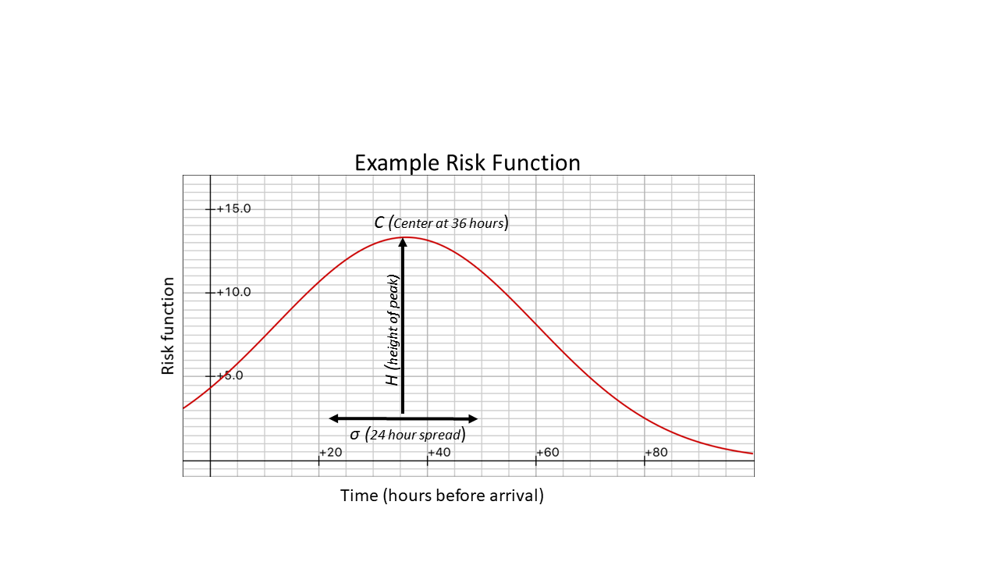

Figure 4. Example time-sensitive risk function calculated by each Cit-ag based on its current interpretation of the hurricane forecast (Step 3 in Table 6 and text). As described in Table 6, *H* is calculated in Step 2 and *C* and *σ* are random variables. The example shown uses a typical value for *H* and mean values for *C* and *σ*.

Step 1:

In the first step, the citizen-agent uses its current interpretation of the forecast (from the *process information* algorithm) to calculate the closest distance between its location and the storm’s track (*dist-trk*).If the Cit-ag thinks that it is in the cone of uncertainty (*dist-trk* < *errbars*), then *dist-trk* is set to 0. The variable *dist-trk* is then re-calculated using eq. 1 below, which is equivalent to setting *dist-trk* = 0.0011; this constant is added to avoid division by 0 in step 2.

If the Ccitizen-agent thinks that it is not in the cone of uncertainty, the anticipated distance from the storm track (*dist-trk*) is rescaled for use in the risk function described below, incorporating the track uncertainty at that forecast lead time (*error-bars*). Specifically:

*dist-trk* = $\frac{scale* dtrack}{2}*\frac{.0011}{errbars}+.0011$. (1)

Functionally, *dist-trk* will have its smallest value (a constant) when the Cit-ag thinks it is in the cone of uncertainty. If the citizen-agent does not think that it is the cone of uncertainty, *dist-trk* will be smaller when: a) the citizen-agent’s forecast interpretation predicts that the storm will come closer to the citizen-agent’s location; and b) the track forecast uncertainty at the forecasted time of closest arrival larger (either because there is more time until arrival or the track forecasts have less uncertainty overall).

Step 2:

Next, the peak height *H* of the Cit-ag’s risk function curve for that time step (Fig. 4) is calculated based on dist-trk (calculated in Step 1), the evacuation zone value (zone) and intensity related to the the storm’s forecasted intensity at the time of closest arrival (based on whether the intensity is greater than or equal to 95 kt, equivalent to a category 3 storm). Specifically:

*H* = $1/\sqrt{2π*[ dist_trk +(.003*zone_rev)+\left(.000525*intensity_rev\right)]}$ (2)

The constants serve to transform the scale of the resulting curve to match the scale of the risk thresholds (*risk-life*, *risk-property*, *info-up*, *info-down*) described above. Functionally, an agent that thinks it is in an evacuation zone (*zone* = 0) and closer to the storm track of a higher intensity storm (*dist-trk* smaller*, intensity* = 0) will have a risk function with a higher peak.

Step 3:

In Step 3, the citizen-agent uses its interpretation of the forecast to calculate the time until the storm will reach its closest point (*x*). In addition, the height *H* calculated in step 2 is used to inform a bell curve calculated:

*risk function* = $H*e^{-\frac{{(time-C)}^{2}}{2*σ^{2}}}$ (3)

where *C* and *σ* are random variables that are dynamic and vary across the citizen-agent population, as defined in Table 6. An example curve, based on a representative value for *H* and mean values for *C* and *σ*, is shown above in Figure 4, with *time* (time until the storm’s arrival) as the x-axis.

The value of the risk function curve at *time* = *x*, which represents the time at which the agent (based on its interpretation of the forecast) thinks the storm will reach its closest point, becomes the citizen-agent’s preliminary risk assessment based on the forecast information (*risk-estimate*). The input variable *C* represents the time at which the risk function reaches its peak; thus, the citizen-agent is more likely to evacuate or take other action based on forecast information when *x* is closer to *C*. The input variable *σ* represents the width of the risk function curve; when *σ* is larger, the curve will be wider, and thus the citizen-agent’s likelihood of taking action is less sensitive to the difference between the time of the storm’s anticipated arrival (*x*) and *C*. In practice, the risk estimate will be low for most citizen-agents most of the time. Only when the timing is right and other risk factors (such as the agent’s interpretation of the forecasted storm track and intensity) align will the citizen-agent calculate a relatively high value for perceived risk based on forecast information.

Step 4:

A small amount of error is added to the *risk-estimate* value calculated above: a normally distributed random value centered on zero with a standard deviation of 0.5 If evacuation orders have been issued by the closest Official agent, a value of 6 * *trust-authority?* is added to the citizen-agent’s overall risk assessment if it believes it is in an evacuation zone, or a value of 2.4 * *trust-authority?* to its overall risk assessment otherwise. If environmental cues are present, in other words, if winds exceed 34 kt at the citizen-agent’s location, a value of 3 is added to *risk-estimate* to set the final value of the citizen-agent’s risk assessment.

4.2.4 Make decision

To decide which actions, if any, to take, the citizen-agent compares the final risk assessment value output from Step 4 with its risk thresholds. This comparison determines what, if any, protective action the agent decides to pursue.

*Risk-estimate* values above the *risk-life*, *risk-property*, and *increase-info* thresholds trigger the citizen-agent to decide to evacuate, take other protective action, and increase its information collection frequency (decrease *feedback1*), respectively. *Risk-estimate* values below *decrease-info* cause the agent to run its decision algorithm less frequently (increase *feedback1*). If the *risk-estimate* value is between the *decrease-info* and *increase-info* thresholds, Cit-ags take no action; they simply go back to being dormant until the next time interval *feedback1* has passed.

*4.3 “Finished” Citizen-Agents*

Citizen-Agents that complete the Decision Model and decide to evacuate will stop running the assess risk and decision steps of the Decision Model. They do, though, continue to participate in the information networks, by running the same code as the first two steps of the Decision Model (*collect*, *process* information) at time steps when they are active. To determine their dormant/active schedule, these citizen-agents revert to their original parameter setting for the number of time steps between running the relevant code (value of *feedback1* set at initialization).

**5. Formats for Supporting Files and Key Variables**

This section provides detail on the formats, sources, and naming conventions for the input files shown in Table 1a and 1b. This section also includes some details on the parsing of information in the forecast variables. Note that input files for each of the storms (and their real/ideal variants) are structurally the same as the examples shown below, but with the data specific to those storms.

Input file – Map projection file, a short text file read in by the GIS extension in NetLogo to set the coordinate system and datum.

Example: block_density.prj

(contents)

GEOGCS ["WGS_84_Geographic", DATUM ["D_WGS_1984", SPHEROID ["WGS_1984",6378137,298.257223563]], PRIMEM["Greenwich",0],

UNIT["Degree",0.017453292519943295]]

Input file – Elevation raster map; meters above sea level. The version used for the Florida map was cropped from SRTM tiles. In order to use the NetLogo GIS extension, the DEM was converted to an ascii grid (.asc) using GRASS GIS. Projection must match the .prj file listed above. Once these data are imported into the model, the grid-cells are assigned an elevation value (NetLogo documentation is not clear on the method, but it looks to be a nearest-neighbor method for resampling).

Example: Florida_SRTM_1215.asc

(contents)

[large raster map]

Input file – Population density raster map; persons per pixel. The version used for the Florida map was developed from a TIGER/Line shapefile for the year 2000 census. The original vector map was converted to an ascii grid raster map (.asc) using GRASS GIS. Projection must match the .prj file listed above. Once these data are imported into the model, the grid-cells are assigned a population density value later used for locating citizen agents on the map (NetLogo documentation is not clear on the method, but it looks to be a nearest-neighbor method for resampling). This file is only necessary if you choose to distribute citizen-agents based on population density.

Example: Pop_Density_1215.asc

(contents)

[large raster map]

Input file – County raster map; county code per pixel. The version used for the Florida map was developed from a shapefile of Florida county boundaries. The original vector map was converted to an ascii grid raster map (.asc) using GRASS GIS. Projection must match the .prj file listed above. Once these data are imported into the model, the grid-cells are assigned a county code value later used by the Official agents (NetLogo documentation is not clear on the method, but it looks to be a nearest-neighbor method for resampling).

Example: counties_1.asc

(contents)

[large raster map]

Input file – County seats vector map; point locations for county seats. The version used for Florida was a shapefile of Florida county seat locations digitized by the author(s) using GRASS GIS. Projection must match the .prj file listed above. Once these data are imported into the model, the Official agents are assigned a county code and placed at the county seat locations.

Example: county_seats.shp (related files: county_seats.dbf, county_seats.prj, county_seats.shx)

(contents)

[small shapefile map]

Input file – Storm best track data from NOAA/NHC. Model initialization code reads this file to inform the model about the storm. The data include date, time, storm classification, geographical coordinates (lat/lon degrees), maximum sustained winds, central pressure, and radii (nautical miles) of winds at 34, 50, and 64 knots in each of four quadrants (NE SE SW NW), with dates/times typically separated by 6 hours. Comma-delimited text file (both .csv and .txt are okay).

Example: WILMA NEW.csv [see also: CHARLEY.txt]

(contents)

20051019,1800, , HU, 17.4N, 83.4W,140,892,200,200,100,150,75,60,60,75,50,40,40,50,

20051020,0, , HU, 17.9N, 84.0W,135,892,200,200,110,150,75,75,60,75,60,40,40,60,

20051020,600, , HU, 18.1N, 84.7W,130,901,200,200,110,150,75,75,60,75,60,40,40,60,

20051020,1200, , HU, 18.3N, 85.2W,130,910,200,150,110,175,110,85,60,110,75,75,45,75,

20051020,1800, , HU, 18.6N, 85.5W,130,917,175,150,120,175,110,90,75,110,75,75,60,75,

20051021,0, , HU, 19.1N, 85.8W,130,924,175,150,120,175,110,90,75,110,75,75,60,75,

20051021,600, , HU, 19.5N, 86.1W,130,930,175,150,120,175,110,90,75,110,75,75,60,75,

20051021,1200, , HU, 20.1N, 86.4W,125,929,175,175,120,150,100,90,75,100,75,75,60,75,

20051021,1800, , HU, 20.3N, 86.7W,120,926,175,175,120,150,100,100,75,100,75,75,60,75,

20051022,0, , HU, 20.6N, 86.8W,120,930,175,175,120,150,100,100,75,100,75,75,60,75,

20051022,600, , HU, 20.8N, 87.0W,110,935,175,175,120,150,100,100,75,100,75,75,60,75,

20051022,1200, , HU, 21.0N, 87.1W,100,947,175,175,120,150,100,100,75,100,75,75,60,75,

20051022,1800, , HU, 21.3N, 87.1W,85,958,175,175,120,150,100,100,75,100,75,75,50,75,

20051023,0, , HU, 21.6N, 87.0W,85,960,175,175,120,150,100,100,75,90,60,60,50,60,

20051023,600, , HU, 21.8N, 86.8W,85,962,175,175,125,175,100,100,75,90,60,60,40,40,

20051023,1200, , HU, 22.4N, 86.1W,85,961,200,200,125,175,100,100,75,90,60,60,40,40,

20051023,1800, , HU, 23.1N, 85.4W,90,963,200,200,150,150,125,125,90,90,65,75,50,50,

20051024,0, , HU, 24.0N, 84.3W,95,958,200,200,150,150,125,125,90,90,65,75,50,50,

20051024,600, , HU, 25.0N, 83.1W,110,953,200,200,175,150,125,125,100,90,75,80,75,50,

20051024,1200, , HU, 26.2N, 81.0W,95,950,200,225,200,150,125,150,100,90,75,90,75,40,

20051024,1800, , HU, 28.0N, 78.8W,105,955,200,225,200,150,125,150,100,90,75,90,75,40,

20051025,0, , HU, 30.1N, 76.0W,110,955,200,225,250,150,125,150,100,90,75,90,75,40,

20051025,600, , HU, 33.3N, 72.0W,100,963,200,275,375,150,125,150,100,75,75,90,60,40,

20051025,1200, , HU, 36.8N, 67.9W,90,970,200,300,375,175,125,150,100,75,75,90,60,40,

20051025,1800, , HU, 40.5N, 63.5W,75,976,200,300,375,175,125,150,100,75,60,75,45,45,

20051026,0, , EX, 42.5N, 60.0W,60,978,200,300,375,175,125,150,100,75,0,0,0,0,

Input file – index of forecast files (NOAA/NHC advisories or mock advisories). Initial versions of the CHIME model code read this list and proceeds to load each of the listed forecast files. This is not the preferred method for adding in new storms.

Example: WILMA ADVISORIES.txt [see also: CHARLEY_ADVISORIES.txt, FAKE_WILMA ADVISORIES.txt, CHARLEY_IDEAL ADVISORIES.txt]

(contents)

Wilma_For-18.txt

Wilma_For-19.txt

Wilma_For-20.txt

Wilma_For-21.txt

Wilma_For-22.txt

Wilma_For-23.txt

Wilma_For-24.txt

Wilma_For-25.txt

Wilma_For-26.txt

Wilma_For-27.txt

Wilma_For-28.txt

Wilma_For-29.txt

Wilma_For-30.txt

Wilma_For-31.txt

Wilma_For-32.txt

Wilma_For-33.txt

Wilma_For-34.txt

Wilma_For-35.txt

Wilma_For-36.txt

Wilma_For-37.txt

Input files – files with forecast information (NOAA/NHC advisories or mock advisories). Initial versions of the model initialization code parses these text files to extract, e.g., the 9, 21, 33, 45, 69, 93, and 117 hour forecasts (each of which includes location, max wind speeds, pressure, and 64 and 34 kt wind distances in the 4 quadrants) for forecasts created at different times (typically every 6 hours). The remaining text is discarded. See Figure 5 for an example advisory file. This method was only used for storms initially added to the model. The simpler and preferred method is described below.

Example: Charley_adv 02.txt

(contents similar to the following figure)

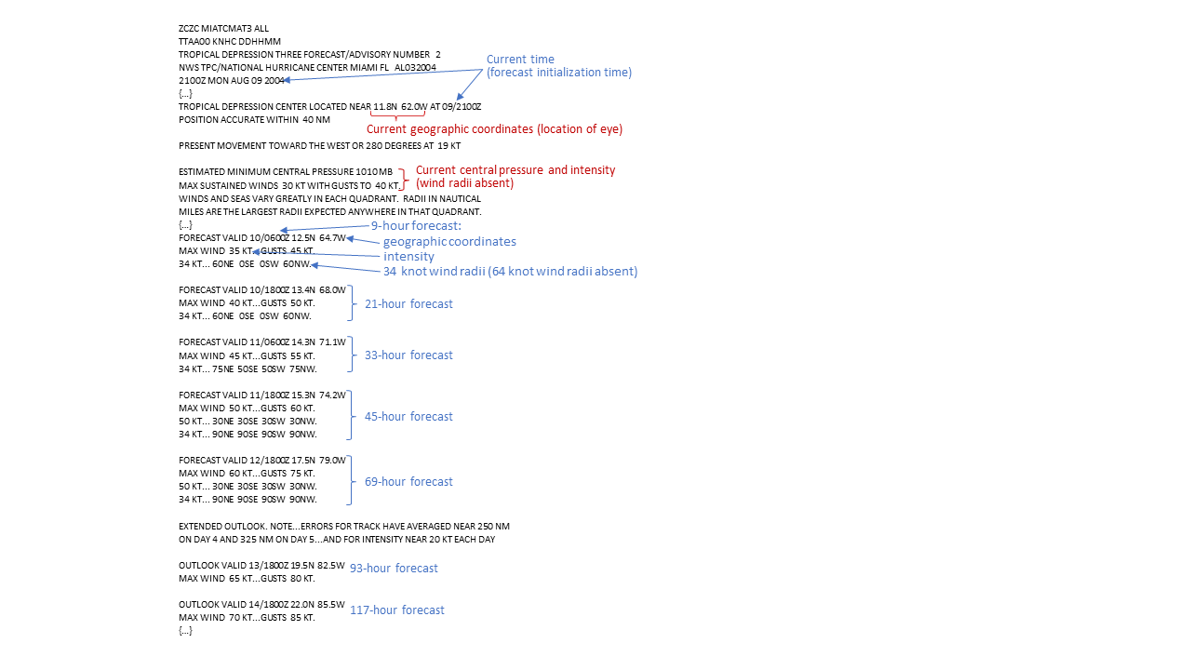

Figure 5. Example Forecast Advisory issued for Hurricane Charley. This advisory is stored in file Charley_adv 02.txt and read into the model at setup. The information marked in blue is then extracted into the forecast information used in the model as described in section 3.

Input files – Instead of the index file and individual storm forecast advisory files mentioned previously, a single .csv with forecast information can also be read into the model. This can be achieved by using the procedure Load-Forecast-New. Go to <https://ftp.nhc.noaa.gov/atcf/archive/download> to get new storm information. Storms are listed by year and then by their date. The id for each storm can be found by reading the tropical cyclone reports found here: <https://www.nhc.noaa.gov/data/tcr/> (For example: Wilma, 2005 mid october. Is referred to as AL252005). Unzip the storm advisories file. Rename the .dat file as a .csv format. The acronyms in the 5th column denote different forecast models. Next delete all rows that have anything except OFCL in the 5th column. The resulting .csv file can be read in with the procedure Load-Forecast-New. An example of such a file is “irma_advisores.csv.”

After the forecast files are loaded, the data are parsed by the model to extract information about the forecasts. An example of parsed data is shown here:

1. time advisory was issued, day of the month and hour
2. followed by 7 (usually) forecasts at 12, 24, 36, 48, 72, 96, 120 hours

each of the forecasts includes information about time, location, and winds:

* day for the forecast
* hour for the forecast
* x-coordinate converted to NetLogo grid, forecast eye location
* y-coordinate converted to NetLogo grid, forecast eye location
* max sustained winds forecast knots
* radii in nautical miles of 34 kt winds in [NE, SE, SW, NW] quadrants (placeholder “” quotes indicate no information available in the advisory)
* radii in nautical miles of 64 kt winds in [NE, SE, SW, NW] quadrants (placeholder “” quotes indicate no information available in the advisory)

[[9 2100]

[10 600 -281.61433068200563 358.1619173428946 35 [60 0 0 60] ""]

[10 1800 -264.9381871100329 294.10670476909365 40 [75 50 50 75] ""]

[11 600 -248.26204353806023 233.93362629067465 45 [90 90 90 90] ""]

[11 1800 -229.73299512475722 173.76054781225537 50 [90 90 90 90] ""]

[12 1800 -188.96908861549062 80.58932952309034 60 "" ""]

[13 1800 -151.91099178888464 12.651982853907459 65 "" ""]

[14 1800 -105.58837075562714 -45.58002857682072 70 "" ""]]

This information is repeated for each of the NHC advisories loaded into the model and saved as the *forecast-matrix* variable.